AI WeatherWise: AI-Powered Weather Insights API
Team ID: SWTID-2026-8575 | Date: 25/09/2026
Project Description:
AI WeatherWise is a RESTful backend API that combines live weather data with Generative AI to give people clear, practical weather guidance. It is built with Node.js and Express.js and stores its data in MongoDB Atlas through the Mongoose ODM. Users register and log in to receive a JWT token, look up the current weather for a city (temperature, humidity, wind speed and condition), and request an AI-written recommendation based on those conditions.
The recommendations are produced by an AI service layer built around Google Gemini. The platform protects its endpoints with JWT authentication, bcrypt password hashing and payload validation, and uses custom error handling and request sanitization to keep the API reliable across all routes.
Scenarios
Scenario 1: A new user registers and logs in to receive a JWT token. They then request the weather for Chennai and get the temperature, humidity, wind speed and condition. Sending the temperature and condition to the AI recommendation endpoint returns advice such as staying hydrated and wearing light cotton clothes.
Scenario 2: A client sends a weather request with a missing or invalid token, or with a malformed JSON body. The authentication and validation checks reject it with a clear error status (401 Unauthorized or 400 Bad Request) and no data reaches the AI service.
Scenario 3: An administrator sets up the environment variables (database URI, JWT secret and Gemini API key), starts the server, confirms the database connection in the terminal, and verifies the protected endpoints with Postman or Thunder Client.

Technical Architecture:
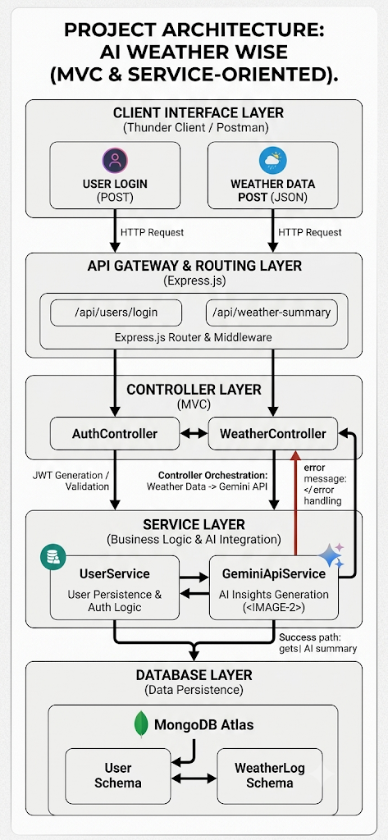
Description: AI WeatherWise follows the MVC (Model-View-Controller) pattern combined with a service-oriented approach to separate request routing, business logic and data persistence. Client requests pass through the Express.js gateway and its middleware to the controllers, which hand AI work to the Gemini service and data work to the user service and Mongoose models stored in MongoDB Atlas.
Entity-Relationship (ER) Diagram
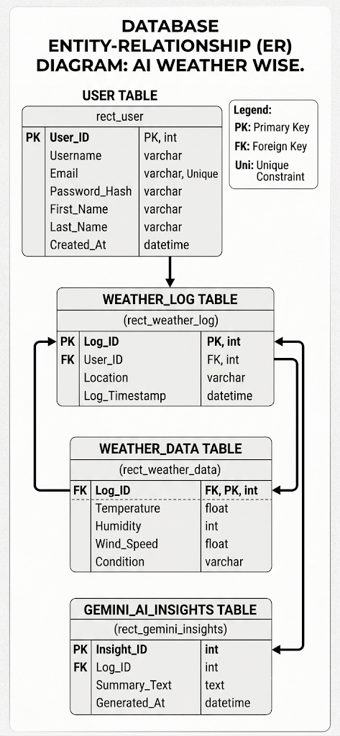
Description: The database is organised around four related tables. A User can own many Weather_Log records; each Weather_Log holds one set of Weather_Data readings (temperature, humidity, wind speed and condition) and links to the Gemini_AI_Insights record that stores the generated summary text and its timestamp.
Pre-requisites:
- Node.js (v16 or above): runtime for the server logic and routing
- npm (v8 or above): package manager for project dependencies
- Git: version control
- MongoDB Atlas Account: active cluster for the cloud database
- Google Gemini API Key: obtained from Google AI Studio
- API Client: Postman or the Thunder Client extension for Visual Studio Code
- Code Editor: Visual Studio Code
- Hardware: Intel Core i3 (8th Gen) / AMD Ryzen 3 or better, 4 GB RAM minimum (8 GB recommended), 500 MB free disk space

Project Workflow:
Milestone 1: Project Architecture and Requirements
- Activity 1.1: Identify the software and hardware requirements.
- Activity 1.2: Define the MVC and service-oriented architecture of the API.
- Activity 1.3: Design the entity-relationship structure for users, weather logs, weather data and AI insights.
Milestone 2: Project Setup and Configuration
- Activity 2.1: Install the prerequisites and create the project directory structure.
- Activity 2.2: Install the required dependencies and configure the environment variables.
- Activity 2.3: Add the start scripts and verify the terminal output.
Milestone 3: Backend Development
- Activity 3.1: Build the controllers, routes and middleware.
- Activity 3.2: Write the server.js entry point that connects everything and starts the server.
Milestone 4: Database Configuration
- Activity 4.1: Connect to MongoDB Atlas using Mongoose.
- Activity 4.2: Define the User and Location schemas.
Milestone 5: Project Execution and API Testing
- Activity 5.1: Run the backend server and confirm the database connection.
- Activity 5.2: Test the Register, Login, Weather and Recommendation APIs.
Milestone 6: Conclusion

Milestone 1: Project Architecture and Requirements
This milestone lays the foundation of AI WeatherWise by fixing the tools it needs, the way its layers interact, and the shape of its data.
Activity 1.1: Software and Hardware Requirements
- Operating System: Windows 10/11, macOS or Linux
- Node.js and npm: Node.js v16+ and npm v8+ to run the server and manage packages
- MongoDB and Mongoose: NoSQL database with an ODM for schema validation and modelling
- Postman / Thunder Client: to send requests and check JSON responses
- Hardware: Intel Core i3 (8th Gen) / AMD Ryzen 3 or equivalent, 4 GB RAM (8 GB recommended), 500 MB storage
Activity 1.2: Define the Architecture of the Application
The API is organised into four layers that keep each concern separate:
- Model Layer: Mongoose schemas for the User and Weather data, including validation rules, stored in MongoDB Atlas.
- View Layer: Because this is a headless API, the view is the routing and network interface: /api/auth/register, /api/auth/login, /api/weather/:city and /api/ai/weather-recommendation receive requests and return structured JSON.
- Controller Layer: AuthController handles registration, credential checks and JWT generation. WeatherController returns the weather for a city, and the AI controller validates the weather details, passes them to the AI service and formats the response.
- Service Layer: GeminiApiService calls Google Gemini AI to write the weather recommendation, and UserService handles password hashing with bcrypt and database mapping.
Activity 1.3: Entity-Relationship Structure
Users are stored with a username, a unique email, a hashed password and a creation date. Each user can create many weather logs, and every log is linked to its weather readings and its generated AI insight, as shown in the ER diagram above.
Key Features
- JWT Authentication: secure token generation and verification for login sessions.
- Protected Routes: middleware restricts weather endpoints to token holders.
- AI Recommendations: Gemini turns the temperature and condition into practical, readable advice.
- Validation and Sanitization: required fields are checked before any processing or database write.
User Flow
1. The user registers (POST /api/auth/register) and logs in (POST /api/auth/login) to receive a JWT access token.
2. The user adds the token to the Authorization header of later requests.
3. The user fetches the weather for a city (GET /api/weather/chennai).
4. The user sends the temperature and condition to POST /api/ai/weather-recommendation.
5. Invalid requests are rejected with a 400 or 401 error; valid data goes to GeminiApiService, which generates the advice.
6. The server returns 200 OK with the AI-generated recommendation:
{
"success": true,
"recommendation": "Stay hydrated, wear light cotton clothes, and a light jacket might be handy."
}
Milestone 2: Project Setup and Configuration
This milestone explains how to install, configure and run the AI WeatherWise backend on a local machine.
Activity 2.1: Directory and File Structure
The workspace is organised according to the MVC pattern:
ai-weatherwise-backend/
├── config/ db.js (MongoDB Atlas connection)
├── controllers/ authController.js, weatherController.js
├── middleware/ authMiddleware.js, errorHandler.js
├── models/ User.js, WeatherLog.js
├── routes/ authRoutes.js, weatherRoutes.js
├── services/ geminiService.js (Gemini AI integration)
├── .env environment variables
├── .gitignore node_modules, .env
├── package.json dependencies and scripts
└── server.js Express server entry point
Activity 2.2: Installation Steps
- Step 1: Create the project folder and open it.
mkdir ai-weatherwise-backend
cd ai-weatherwise-backend

- Step 2: Initialize a Node.js project to generate package.json.
npm init -y

- Step 3: Install the required dependencies (Express, Mongoose, dotenv, JWT, bcrypt, the Google Generative AI SDK and CORS), plus nodemon for development.
npm install express mongoose dotenv jsonwebtoken bcryptjs @google/generative-ai cors
npm install -D nodemon
Activity 2.3: Environment Variables (.env)
Create a .env file in the project root and set these values:
# Server Configuration
PORT=5001

# MongoDB Atlas Database Connection
MONGO_URI=mongodb+srv://<username>:<password>@cluster0.ad723.mongodb.net/ai_weatherwise?retryWrites=true&w=majority

# JWT Authentication Secret Key
JWT_SECRET=your_super_secret_jwt_key_here

# Google Gemini AI Service API Key
GEMINI_API_KEY=your_google_gemini_api_key_here
Activity 2.4: Running the Application
Add the start scripts to package.json:
"scripts": {
"start": "node server.js",
"dev": "nodemon server.js"
}

On a successful start the terminal shows the nodemon messages, then a MongoDB connection message and the port number:
[nodemon] starting `node server.js`
MongoDB Connected: cluster0.ad723.mongodb.net
Server running on port 5001

Test the server with Postman or Thunder Client at these endpoints:
- User Login (POST): http://localhost:5001/api/auth/login
- Weather (GET): http://localhost:5001/api/weather/chennai
- AI Recommendation (POST): http://localhost:5001/api/ai/weather-recommendation
Milestone 3: Backend Development
Activity 3.1: Project File Structure
The completed backend contains controllers for AI, authentication, locations and weather, matching routes, an authentication middleware, and the User and Location models.
ai-weatherwise-backend/
├── config/ db.js
├── controllers/ aiController.js, authController.js,
│ locationController.js, weatherController.js
├── middleware/ authMiddleware.js
├── models/ Location.js, User.js
├── routes/ aiRoutes.js, authRoutes.js,
│ locationRoutes.js, weatherRoutes.js
├── services/
├── app.js
├── server.js
├── .env, .gitignore
├── package.json, package-lock.json
├── postman_collection.json
└── README.md
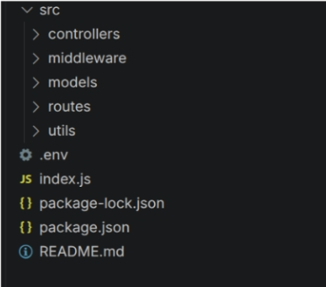
Activity 3.2: Application Entry Point (server.js)
server.js is the main entry point. It loads the environment variables, initializes the Express server, configures the middleware, connects to MongoDB, registers the API routes, and starts listening only after the database connection succeeds.
Milestone 4: Database Configuration
Activity 4.1: Database Connection
The database module uses the Mongoose ODM to open an asynchronous connection to the MongoDB Atlas cluster hosted in the cloud.
The module establishes the connection between the application and MongoDB using Mongoose, so the backend can talk to the database before it handles any client request.
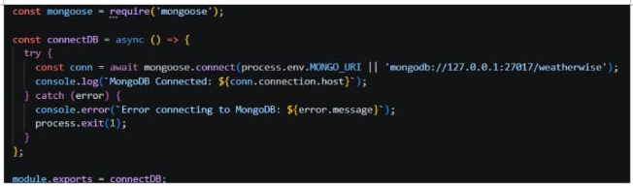
Activity 4.2: Location Schema
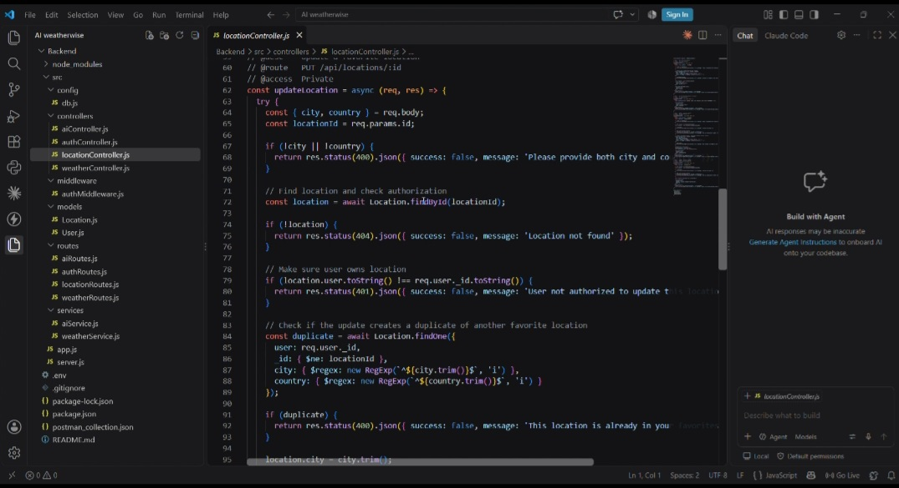

Milestone 5: Project Execution and API Testing
Activity 5.1: Server Setup and Database Connection
Objective: confirm that the Express server starts and connects to MongoDB Atlas. The server listens on port 5001 and the terminal reports a successful database connection.
Activity 5.2: Running the Backend Server
- Step 1: Install dependencies with npm install.
- Step 2: Make sure the .env file contains MONGO_URI, PORT, JWT_SECRET and GEMINI_API_KEY.
- Step 3: Start the server with the configured start script (npm start or npm run dev).
- Step 4: Check that the server starts on the chosen port and connects to MongoDB.
Activity 5.3: Core Modules Tested
- User Authentication: a valid login returns a JWT token.
- Weather API: a GET request for a city returns 200 OK with its temperature, humidity, wind speed and condition.
- AI Recommendation: the request carries the temperature and condition; the response is 200 OK with success set to true and the generated recommendation.
- Mongoose Models: the User schema enforces a username, a unique email and password validation; the Location schema stores a user's saved locations (city, country and user reference) with a compound index that prevents duplicate entries.

Exploring the API Endpoints:
Register API:
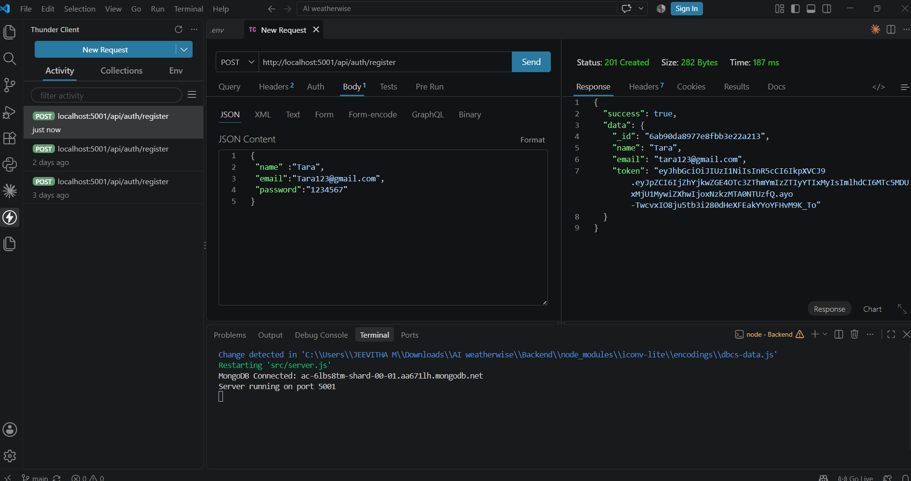
Login API:
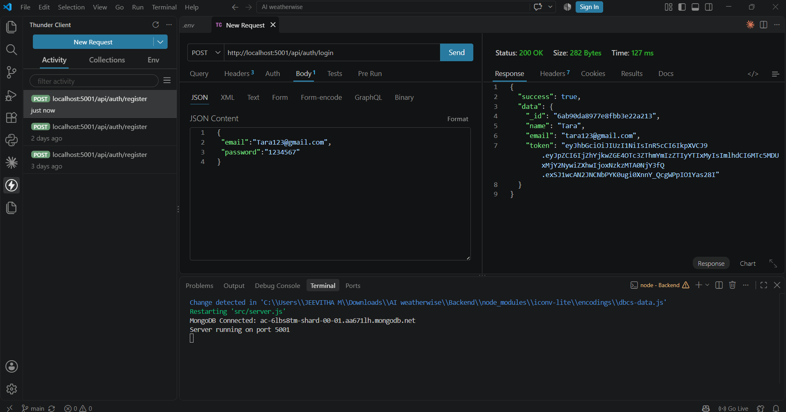
Weather API:
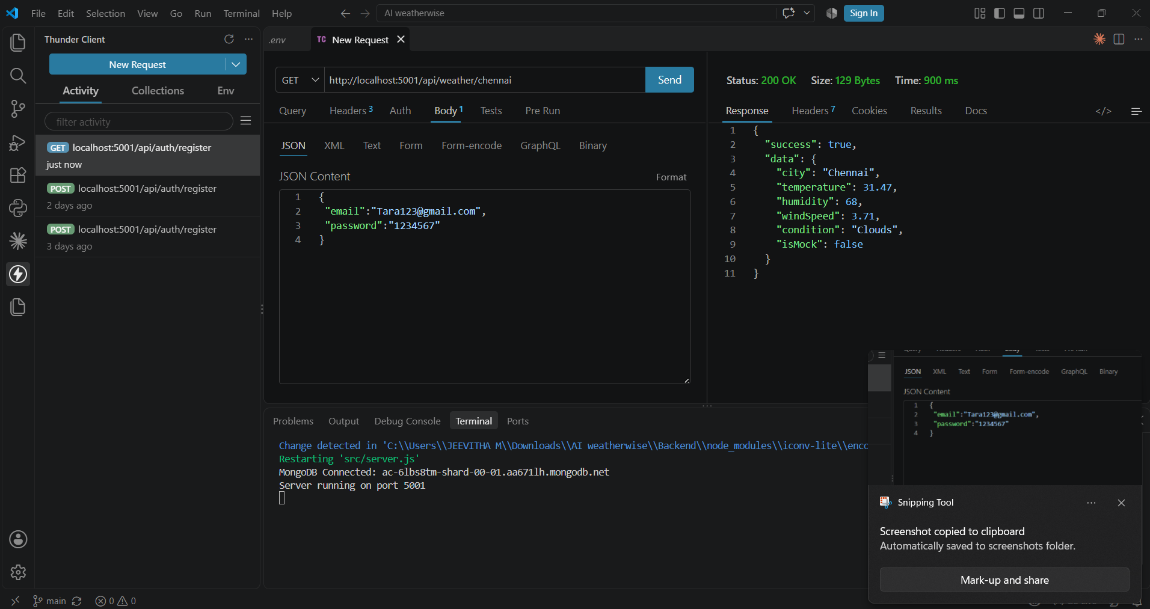
Recommendation API:
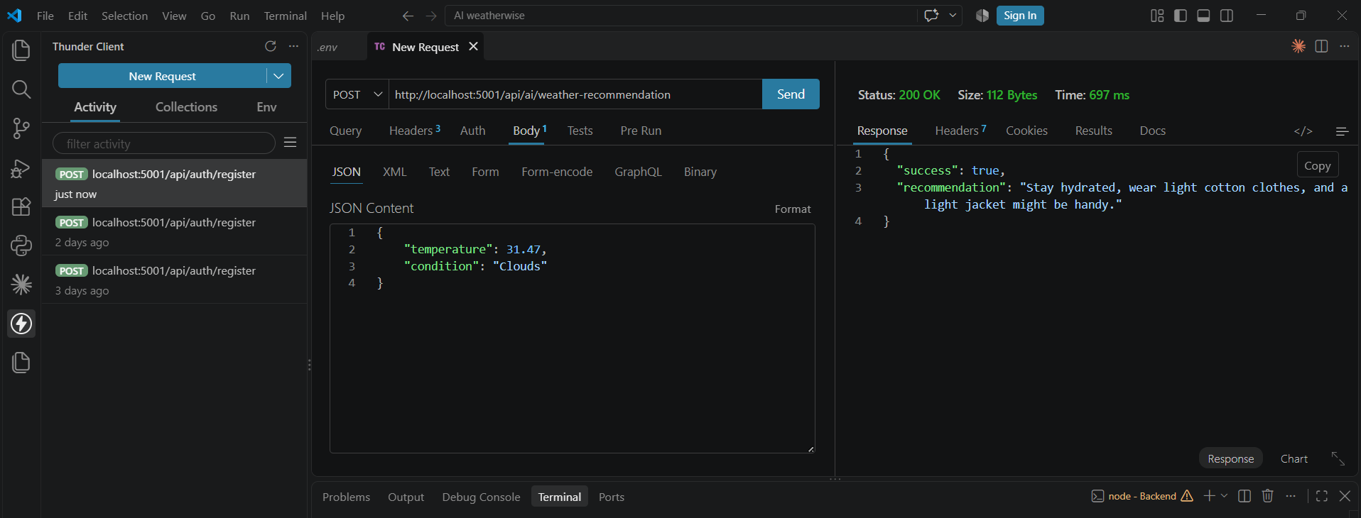
API Testing Video Link:

Demo Video Link:

Milestone 6: Conclusion
AI WeatherWise is a secure, layered backend API built with Node.js, Express.js and MongoDB Atlas that uses Google Gemini AI to turn weather readings into clear, practical recommendations. JWT authentication, bcrypt hashing and request validation protect every route, while the MVC and service-oriented design keeps the code easy to extend. The project covered architecture design, environment setup, backend and database development, and thorough API testing. Future improvements could include live weather data feeds, multi-language advice, and saved weather history for each user.

